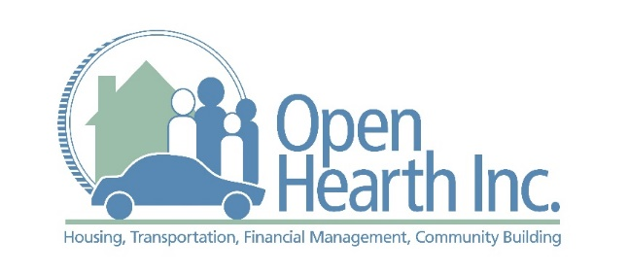

Goal Achievement Program (GAP)

Overview: The Goal Achievement Program (GAP) is Open Hearth’s homelessness prevention program that provides short-term, decreasing level rent payment assistance to those who are at risk of becoming homeless due to an unforeseen, short-term financial crisis. GAP follows the progressive engagement model, as we tailor our assistance on a case by case basis, providing the appropriate amount of assistance needed to resolve the housing crisis. More importantly, our budgeting assistance, goal planning and financial counseling offers participants the tools to prepare for an unexpected financial hardship and to prevent risk of future housing insecurity.

Service Area:

Northern Chester County
- Greater Phoenixville
- Spring City
- The Vincents
- The Coventrys
- The Pikelands

Western Montgomery County
- Limerick
- Royersford
- Upper and Lower Providence
- Collegeville
- Trappe
- Lower Pottsgrove

Eligibility:

Renter residing in Northern Chester County or western Montgomery County

Must have an active lease agreement

Must have a source of income or guarantee of imminent income – proof of income for entire household from past 30 days required

Eligibility Screening: Contact Rebecca Rush, Housing Programs Manager, at 610-792-9282, x207 or rrush@openhearthinc.org

